fintech_wallet | SBP
V1.0

Revision History
Version | Date | Description | Author
1.0 | 18/02/2026 | Initial Version | Mohammed Megahed

Reviewers
# | Name | Position | Date and Signature
1
2

Acceptance and Signoff
# | Name | Position | Date and Signature
1
2

Contents
Right-click and select 'Update Field' to generate Table of Contents

1. Introduction

1.1. Project Summary
This project builds a comprehensive digital wallet platform enabling secure user registration, KYC verification, multi-currency wallets, P2P transfers, and domestic bank transfers. Key capabilities include multi-currency wallets, P2P transfers, KYC verification, user registration, and sanctions screening. Primary business benefit is increased financial inclusion and efficiency.

1.2. In-Scope
# | Item
1. | User registration with mobile OTP verification
2. | KYC verification via national ID and selfie capture
3. | Multi-currency wallet creation and management (SAR, USD, AED)
4. | P2P transfers to other FinWallet users
5. | Domestic bank transfers via SARIE
6. | Bill payments via SADAD integration
7. | Wallet top-up via card and Apple Pay

1.3. Out-Scope
# | Item
1. | International remittances via SWIFT
2. | Physical card issuance
3. | Merchant onboarding and management
4. | Cryptocurrency transactions

1.4. Target Audience
# | Stakeholders
1. | Enterprise Architects
2. | Partners and Vendors Technical Leaders
3. | Infrastructure Architects & Engineers
4. | InfoSec Architects & Engineers
5. | Technical Managers
6. | Delivery Leads and Project Managers
7. | Developers

1.5. Abbreviations
# | Abbreviations | Full form
1

1.6. Assumptions, Dependencies and Risks
# | Item | Type | Owner | Comment
1.
2.

2. Requirements Compliancy Matrix
ID. | Title | Description | Compliancy | Comments
FR-1 | FinWallet is a comprehensive digital wallet platform enabling users to store fun | This requirement enables finwallet is a comprehensive digital wallet platform enabling users to store fun functionality for users. | Compliant
FR-2 | The platform supports multi-currency wallets, P2P transfers, bill payments, and | This requirement enables the platform supports multi-currency wallets, p2p transfers, bill payments, and functionality for users. | Compliant
FR-3 | Integration with national ID verification (Elm Yakeen) ensures KYC compliance | This requirement enables integration with national id verification (elm yakeen) ensures kyc compliance functionality for users. | Compliant
FR-BR-001 | User Registration | This requirement enables user registration functionality for users. | Compliant
FR-BR-002 | apture | This requirement enables apture functionality for users. | Compliant
FR-BR-003 | erification | This requirement enables erification functionality for users. | Compliant
FR-BR-004 | Sanctions Screening | This requirement enables sanctions screening functionality for users. | Compliant
FR-BR-005 | Wallet Creation | This requirement enables wallet creation functionality for users. | Compliant
FR-BR-006 | Multi-Currency | This requirement enables multi-currency functionality for users. | Compliant
FR-BR-007 | Balance Display | This requirement enables balance display functionality for users. | Compliant
FR-BR-008 | P2P Transfer | This requirement enables p2p transfer functionality for users. | Compliant
FR-BR-009 | Bank Transfer | This requirement enables bank transfer functionality for users. | Compliant
FR-BR-010 | Bill Payment | This requirement enables bill payment functionality for users. | Compliant

3. Solution Architecture

3.1. Solution Description
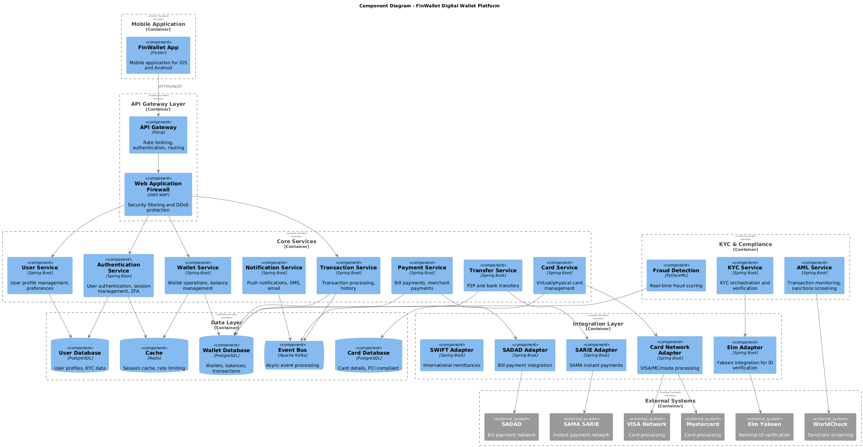

3.2. Non-Functional Requirements
# | Category | Requirement | Target/SLA
1 | Performance | API Response Time | < 2 seconds for 95th percentile
2 | Performance | Transaction Throughput | Support 100 TPS during peak hours
3 | Availability | System Uptime | 99.9% availability (excluding planned maintenance)
4 | Availability | Recovery Time Objective (RTO) | < 4 hours
5 | Availability | Recovery Point Objective (RPO) | < 1 hour
6 | Scalability | Horizontal Scaling | Support auto-scaling based on load
7 | Scalability | Concurrent Users | Support 1000 concurrent users
8 | Data Retention | Transaction Logs | Retain for 7 years as per regulatory requirements
9 | Data Retention | Audit Logs | Retain for 5 years
10 | Compliance | Regulatory | Comply with CMA and SAMA regulations
11 | Compliance | Data Protection | Comply with data privacy requirements

3.3. Security Considerations
# | Security Domain | Requirement | Implementation
1 | Authentication | User Authentication | OAuth 2.0 / JWT tokens with secure token storage
2 | Authentication | Service-to-Service Auth | Mutual TLS (mTLS) for internal service communication
3 | Authentication | Multi-Factor Authentication | MFA required for sensitive operations
4 | Authorization | Role-Based Access Control | RBAC implemented with principle of least privilege
5 | Authorization | API Authorization | Scope-based access control for API endpoints
6 | Data Protection | Data in Transit | TLS 1.2+ encryption for all network communication
7 | Data Protection | Data at Rest | AES-256 encryption for sensitive data storage
8 | Data Protection | PII/Sensitive Data | Data masking and tokenization for sensitive fields
9 | API Security | Input Validation | Server-side validation of all input parameters
10 | API Security | Rate Limiting | Rate limiting to prevent abuse and DDoS attacks
11 | API Security | CORS Policy | Strict CORS policy for web API endpoints
12 | Audit & Logging | Audit Trail | Log all security-relevant events with timestamps
13 | Audit & Logging | Log Protection | Immutable logs with tamper detection
14 | Vulnerability Management | Security Scanning | Regular SAST/DAST scanning in CI/CD pipeline
15 | Vulnerability Management | Dependency Scanning | Automated scanning for vulnerable dependencies

4. User Registration and KYC Flow

4.1. Sequence Diagram
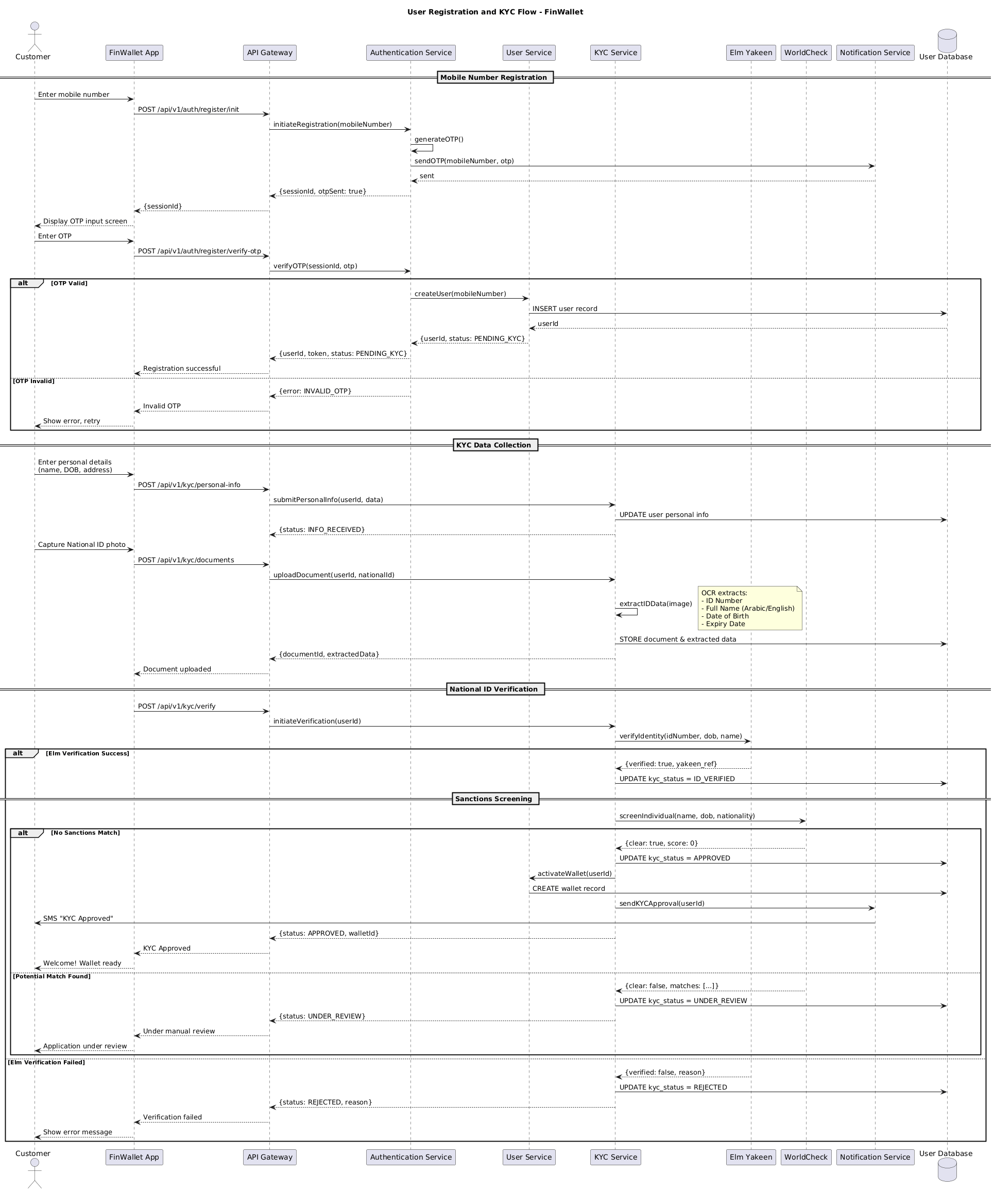

4.2. Flow Description
  - Mobile Number Registration
• Customer Enters Mobile Number: The customer initiates the registration process by entering their mobile number into the FinWallet app.
• API Gateway Initiates Registration: The app sends a POST request to the API Gateway to initiate the registration process.
• Authentication Service Generates OTP: The API Gateway forwards the request to the Authentication Service, which generates an OTP and sends it to the customer via the Notification Service.
• Customer Enters OTP: The customer enters the OTP provided by the Notification Service.
• OTP Verification: The Authentication Service verifies the OTP and sends the result back to the API Gateway.
• Registration Success: If the OTP is valid, the Authentication Service creates a new user record in the User Service and the API Gateway confirms the registration success to the app. If the OTP is invalid, the app informs the customer of the error and prompts them to retry.
  - KYC Data Collection
• Customer Enters Personal Details: The customer provides their personal details such as name, date of birth, and address to the app.
• Capture National ID Photo: The app captures a photo of the customer's national ID.
• KYC Service Processes Data: The app sends a POST request to the KYC Service to submit the personal information and a photo of the national ID. The KYC Service processes the data and stores it in the User Database.
• OCR Extracts Data: The KYC Service uses OCR to extract the ID number, full name, date of birth, and expiry date from the national ID photo.
• KYC Service Verifies National ID: The KYC Service verifies the national ID using Elm Yakeen and WorldCheck. If the verification is successful, the KYC Service updates the user's KYC status to ID_VERIFIED and activates the wallet. If the verification fails, the KYC Service updates the status to REJECTED.
  - National ID Verification
• KYC Service Verifies National ID: The KYC Service verifies the national ID using Elm Yakeen and WorldCheck.
• Sanctions Screening: If the KYC Service finds no sanctions matches, it updates the KYC status to APPROVED and activates the wallet. If a potential match is found, it updates the status to UNDER_REVIEW and prompts the customer for manual review.
  - Flow Phases
Mobile Number Registration: Handles the initial registration process.
KYC Data Collection: Collects and processes the KYC data.
• National ID Verification: Verifies the national ID and performs sanctions screening.
• Sanctions Screening: Determines if the KYC process should be approved, under review, or rejected based on sanctions screening results.
  - Self-Interactions
• Authentication Service: Internally generates OTPs and handles user registration.
• KYC Service: Internally processes KYC data and verifies national IDs.
WorldCheck: Performs sanctions screening.
  - Notes
• OCR Extracts: The KYC Service extracts ID number, full name, date of birth, and expiry date from the national ID photo.
• Sanctions Screening: If no sanctions matches, the KYC status is APPROVED and the wallet is activated. If a match is found, the KYC status is UNDER_REVIEW and the customer is prompted for manual review.
By following this flow, the FinWallet application ensures a secure and compliant KYC process for new users, including the verification of national IDs and the screening of potential sanctions risks.

4.3. APIs Contract Agreement
# | Source | Destination | API | Protocol | Request Parameters | Response Parameters
1 | FinWallet App | API Gateway | POST /api/v1/auth/register/init | REST |  | {sessionId}
2 | API Gateway | Authentication Service | initiateRegistration | REST | mobileNumber | {sessionId, otpSent: true}
3 | Authentication Service | Notification Service | sendOTP | REST | mobileNumber, otp | sent
4 | FinWallet App | API Gateway | POST /api/v1/auth/register/verify-otp | REST |  | Registration successful
5 | API Gateway | Authentication Service | verifyOTP | REST | sessionId, otp | {userId, token, status: PENDING_KYC}
6 | Authentication Service | User Service | createUser | REST | mobileNumber | {userId, status: PENDING_KYC}
7 | FinWallet App | API Gateway | POST /api/v1/kyc/personal-info | REST |  | Document uploaded
8 | API Gateway | KYC Service | submitPersonalInfo | REST | userId, data | {status: INFO_RECEIVED}
9 | KYC Service | User Database | UPDATE user personal info | JDBC
10 | FinWallet App | API Gateway | POST /api/v1/kyc/documents | REST |  | KYC Approved
11 | API Gateway | KYC Service | uploadDocument | REST | userId, nationalId | {documentId, extractedData}
12 | KYC Service | User Database | STORE document & extracted data | JDBC
13 | FinWallet App | API Gateway | POST /api/v1/kyc/verify | REST |  | Under manual review
14 | API Gateway | KYC Service | initiateVerification | REST | userId | {status: APPROVED, walletId}
15 | KYC Service | Elm Yakeen | verifyIdentity | REST | idNumber, dob, name | {verified: true, yakeen_ref}
16 | KYC Service | User Database | UPDATE kyc_status = ID_VERIFIED | JDBC
17 | KYC Service | WorldCheck | screenIndividual | REST | name, dob, nationality | {clear: true, score: 0}
18 | KYC Service | User Database | UPDATE kyc_status = APPROVED | JDBC
19 | KYC Service | User Service | activateWallet | REST | userId
20 | KYC Service | Notification Service | sendKYCApproval | REST | userId
21 | Notification Service | Customer | SMS "KYC Approved" | REST
22 | KYC Service | User Database | UPDATE kyc_status = UNDER_REVIEW | JDBC
23 | KYC Service | User Database | UPDATE kyc_status = REJECTED | JDBC
[*] Indicates that the data element is optional

4.4. Error Handling
# | Source | Destination | Scenario | Handling
1 | External APIC | ACE-Integration | createInternationalBeneficiaryRequest  Duplicate request detected, service unavailability | Ensure idempotency to avoid duplicates on retry; Log error with correlation ID; Notify user of failure
2 | External APIC | ACE-Integration | getInternationalBeneficiarySupportedCountries  Data not found | Ensure idempotency to avoid duplicates on retry; Log error with correlation ID; Return cached response if available; Notify user of failure
3 | External APIC | ACE-Integration | createRequest  Validation failure | Ensure idempotency to avoid duplicates on retry; Log error with correlation ID; Return error code to upstream caller; Notify user of failure
4 | External APIC | ACE-Integration | submitInternationalBeneficiaryRequest  Partial completion | Ensure idempotency to avoid duplicates on retry; Log error with correlation ID; Queue request for asynchronous retry; Notify user of failure
5 | External APIC | ACE-Integration | updateInternationalBeneficiaryRequest  Validation failure | Ensure idempotency to avoid duplicates on retry; Log error with correlation ID; Return error code to upstream caller; Notify user of failure
6 | External APIC | ACE-Integration | deleteInternationalBeneficiaryRequest  Service unavailability | Ensure idempotency to avoid duplicates on retry; Log error with correlation ID; Return error code to upstream caller; Notify user of failure
7 | External APIC | ACE-Integration | getInternationalBeneficiaryRequest  Data not found | Ensure idempotency to avoid duplicates on retry; Log error with correlation ID; Return cached response if available; Notify user of failure
8 | External APIC | ACE-Integration | listInternationalBeneficiaries  Service unavailability | Ensure idempotency to avoid duplicates on retry; Log error with correlation ID; Return error code to upstream caller; Notify user of failure
9 | External APIC | ACE-Integration | processInternationalBeneficiaryRequest  Validation failure | Ensure idempotency to avoid duplicates on retry; Log error with correlation ID; Return error code to upstream caller; Notify user of failure
10 | External APIC | ACE-Integration | checkInternationalBeneficiaryRequestStatus  Service unavailability | Ensure idempotency to avoid duplicates on retry; Log error with correlation ID; Return error code to upstream caller; Notify user of failure
11 | External APIC | ACE-Integration | sendInternationalBeneficiaryRequestNotification  Service unavailability | Ensure idempotency to avoid duplicates on retry; Log error with correlation ID; Return error code to upstream caller; Notify user of failure
12 | External APIC | ACE-Integration | retrieveInternationalBeneficiaryRequest  Data not found | Ensure idempotency to avoid duplicates on retry; Log error with correlation ID; Return cached response if available; Notify user of failure
13 | External APIC | ACE-Integration | uploadInternationalBeneficiaryRequest  Validation failure | Ensure idempotency to avoid duplicates on retry; Log error with correlation ID; Return error code to upstream caller; Notify user of failure
14 | External APIC | ACE-Integration | loadInternationalBeneficiaryRequest  Service unavailability | Ensure idempotency to avoid duplicates on retry; Log error with correlation ID; Return error code to upstream caller; Notify user of failure
15 | External APIC | ACE-Integration | inquireInternationalBeneficiaryRequestStatus  Service unavailability | Ensure idempotency to avoid duplicates on retry; Log error with correlation ID; Return error code to upstream caller; Notify user of failure
16 | External APIC | ACE-Integration | checkInternationalBeneficiaryRequest  Data not found | Ensure idempotency to avoid duplicates on retry; Log error with correlation ID; Return cached response if available; Notify user of failure
17 | External APIC | ACE-Integration | checkInternationalBeneficiaryRequestStatus  Validation failure | Ensure idempotency to avoid duplicates on retry; Log error with correlation ID; Return error code to upstream caller; Notify user of failure
18 | External APIC | ACE-Integration | checkInternationalBeneficiaryRequestStatus  Partial completion | Ensure idempotency to avoid duplicates on retry; Log error with correlation ID; Queue request for asynchronous retry; Notify user of failure
19 | External APIC | ACE-Integration | checkInternationalBeneficiaryRequestStatus  Service unavailability | Ensure idempotency to avoid duplicates on retry; Log error with correlation ID; Return error code to upstream caller; Notify user of failure
20 | External APIC | ACE-Integration | checkInternationalBeneficiaryRequestStatus  Data not found | Ensure idempotency to avoid duplicates on retry; Log error with correlation ID; Return cached response if available; Notify user of failure
21 | External APIC | ACE-Integration | checkInternationalBeneficiaryRequestStatus  Validation failure | Ensure idempotency to avoid duplicates on retry; Log error with correlation ID; Return error code to upstream caller; Notify user of failure
22 | External APIC | ACE-Integration | checkInternationalBeneficiaryRequestStatus  Partial completion | Ensure idempotency to avoid duplicates on retry; Log error with correlation ID; Queue request for asynchronous retry; Notify user of failure
23 | External APIC | ACE-Integration | checkInternationalBeneficiaryRequestStatus  Service unavailability | Ensure idempotency to avoid duplicates on retry; Log error with correlation ID; Return error code to upstream caller; Notify user of failure
24 | External APIC | ACE-Integration | checkInternationalBeneficiaryRequestStatus  Data not found | Ensure idempotency to avoid duplicates on retry; Log error with correlation ID; Return cached response if available; Notify user of failure
25 | External APIC | ACE-Integration | checkInternationalBeneficiaryRequestStatus  Validation failure | Ensure idempotency to avoid duplicates on retry; Log error with correlation ID; Return error code to upstream caller; Notify user of failure
26 | External APIC | ACE-Integration | checkInternationalBeneficiaryRequestStatus  Partial completion | Ensure idempotency to avoid duplicates on retry; Log error with correlation ID; Queue request for asynchronous retry; Notify user of failure
27 | External APIC | ACE-Integration | checkInternationalBeneficiaryRequestStatus  Service unavailability | Ensure idempotency to avoid duplicates on retry; Log error with correlation ID; Return error code to upstream caller; Notify user of failure
28 | External APIC | ACE-Integration | checkInternationalBeneficiaryRequestStatus  Data not found | Ensure idempotency to avoid duplicates on retry; Log error with correlation ID; Return cached response if available; Notify user of failure
29 | External APIC | ACE-Integration | checkInternationalBeneficiaryRequestStatus  Validation failure | Ensure idempotency to avoid duplicates on retry; Log error with correlation ID; Return error code to upstream caller; Notify user of failure
30 | External APIC | ACE-Integration | checkInternationalBeneficiaryRequestStatus  Partial completion | Ensure idempotency to avoid duplicates on retry; Log error with correlation ID; Queue request for asynchronous retry; Notify user of failure
31 | External APIC | ACE-Integration | checkInternationalBeneficiaryRequestStatus  Service unavailability | Ensure idempotency to avoid duplicates on retry; Log error with correlation ID; Return error code to upstream caller; Notify user of failure
32 | External APIC | ACE-Integration | checkInternationalBeneficiaryRequestStatus  Data not found | Ensure idempotency to avoid duplicates on retry; Log error with correlation ID; Return cached response if available; Notify user of failure
33 | External APIC | ACE-Integration | checkInternationalBeneficiaryRequestStatus  Validation failure | Ensure idempotency to avoid duplicates on retry; Log error with correlation ID; Return error code to upstream caller; Notify user of failure
34 | External APIC | ACE-Integration | checkInternationalBeneficiaryRequestStatus  Partial completion | Ensure idempotency to avoid duplicates on retry; Log error with correlation ID; Queue request for asynchronous retry; Notify user of failure
35 | External APIC | ACE-Integration | checkInternationalBeneficiaryRequestStatus  Service unavailability | Ensure idempotency to avoid duplicates on retry; Log error with correlation ID; Return error code to upstream caller; Notify user of failure
36 | External APIC | ACE-Integration | checkInternationalBeneficiaryRequestStatus  Data not found | Ensure idempotency to avoid duplicates on retry; Log error with correlation ID; Return cached response if available; Notify user of failure
37 | External APIC | ACE-Integration | checkInternationalBeneficiaryRequestStatus  Validation failure | Ensure idempotency to avoid duplicates on retry; Log error with correlation ID; Return error code to upstream caller; Notify user of failure
38 | External APIC | ACE-Integration | checkInternationalBeneficiaryRequestStatus  Partial completion | Ensure idempotency to avoid duplicates on retry; Log error with correlation ID; Queue request for asynchronous retry; Notify user of failure
39 | External APIC | ACE-Integration | checkInternationalBeneficiaryRequestStatus  Service unavailability | Ensure idempotency to avoid duplicates on retry; Log error with correlation ID; Return error code to upstream caller; Notify user of failure
40 | External APIC | ACE-Integration | checkInternationalBeneficiaryRequestStatus  Data not found | Ensure idempotency to avoid duplicates on retry; Log error with correlation ID; Return cached response if available; Notify user of failure
41 | External APIC | ACE-Integration | checkInternationalBeneficiaryRequestStatus  Validation failure | Ensure idempotency to avoid duplicates on retry; Log error with correlation ID; Return error code to upstream caller; Notify user of failure
42 | External APIC | ACE-Integration | checkInternationalBeneficiaryRequestStatus  Partial completion | Ensure idempotency to avoid duplicates on retry; Log error with correlation ID; Queue request for asynchronous retry; Notify user of failure
43 | External APIC | ACE-Integration | checkInternationalBeneficiaryRequestStatus  Service unavailability | Ensure idempotency to avoid duplicates on retry; Log error with correlation ID; Return error code to upstream caller; Notify user of failure
44 | External APIC | ACE-Integration | checkInternationalBeneficiaryRequestStatus  Data not found | Ensure idempotency to avoid duplicates on retry; Log error with correlation ID; Return cached response if available; Notify user of failure
45 | External APIC | ACE-Integration | checkInternationalBeneficiaryRequestStatus  Validation failure | Ensure idempotency to avoid duplicates on retry; Log error with correlation ID; Return error code to upstream caller; Notify user of failure
46 | External APIC | ACE-Integration | checkInternationalBeneficiaryRequestStatus  Partial completion | Ensure idempotency to avoid duplicates on retry; Log error with correlation ID; Queue request for asynchronous retry; Notify user of failure
47 | External APIC | ACE-Integration | checkInternationalBeneficiaryRequestStatus  Service unavailability | Ensure idempotency to avoid duplicates on retry; Log error with correlation ID; Return error code to upstream caller; Notify user of failure
48 | External APIC | ACE-Integration | checkInternationalBeneficiaryRequestStatus  Data not found | Ensure idempotency to avoid duplicates on retry; Log error with correlation ID; Return cached response if available; Notify user of failure
49 | External APIC | ACE-Integration | checkInternationalBeneficiaryRequestStatus  Validation failure | Ensure idempotency to avoid duplicates on retry; Log error with correlation ID; Return error code to upstream caller; Notify user of failure
50 | External APIC | ACE-Integration | checkInternationalBeneficiaryRequestStatus  Partial completion | Ensure idempotency to avoid duplicates on retry; Log error with correlation ID; Queue request for asynchronous retry; Notify user of failure
51 | External APIC | ACE-Integration | checkInternationalBeneficiaryRequestStatus  Service unavailability | Ensure idempotency to avoid duplicates on retry; Log error with correlation ID; Return error code to upstream caller; Notify user of failure
52 | External APIC | ACE-Integration | checkInternationalBeneficiaryRequestStatus  Data not found | Ensure idempotency to avoid duplicates on retry; Log error with correlation ID; Return cached response if available; Notify user of failure
53 | External APIC | ACE-Integration | checkInternationalBeneficiaryRequestStatus  Validation failure | Ensure idempotency to avoid duplicates on retry; Log error with correlation ID; Return error code to upstream caller; Notify user of failure
54 | External APIC | ACE-Integration | checkInternationalBeneficiaryRequestStatus  Partial completion | Ensure idempotency to avoid duplicates on retry; Log error with correlation ID; Queue request for asynchronous retry; Notify user of failure
55 | External APIC | ACE-Integration | checkInternationalBeneficiaryRequestStatus  Service unavailability | Ensure idempotency to avoid duplicates on retry; Log error with correlation ID; Return error code to upstream caller; Notify user of failure
56 | External APIC | ACE-Integration | checkInternationalBeneficiaryRequestStatus  Data not found | Ensure idempotency to avoid duplicates on retry; Log error with correlation ID; Return cached response if available; Notify user of failure
57 | External APIC | ACE-Integration | checkInternationalBeneficiaryRequestStatus  Validation failure | Ensure idempotency to avoid duplicates on retry; Log error with correlation ID; Return error code to upstream caller; Notify user of failure
58 | External APIC | ACE-Integration | checkInternationalBeneficiaryRequestStatus  Partial completion | Ensure idempotency to avoid duplicates on retry; Log error with correlation ID; Queue request for asynchronous retry; Notify user of failure
59 | External APIC | ACE-Integration | checkInternationalBeneficiaryRequestStatus  Service unavailability | Ensure idempotency to avoid duplicates on retry; Log error with correlation ID; Return error code to upstream caller; Notify user of failure
60 | External APIC | ACE-Integration | checkInternationalBeneficiaryRequestStatus  Data not found | Ensure idempotency to avoid duplicates on retry; Log error with correlation ID; Return cached response if available; Notify user of failure
61 | External APIC | ACE-Integration | checkInternationalBeneficiaryRequestStatus  Validation failure | Ensure idempotency to avoid duplicates on retry; Log error with correlation ID; Return error code to upstream caller; Notify user of failure
62 | External APIC | ACE-Integration | checkInternationalBeneficiaryRequestStatus  Partial completion | Ensure idempotency to avoid duplicates on retry; Log error with correlation ID; Queue request for asynchronous retry; Notify user of failure
63 | External APIC | ACE-Integration | checkInternationalBeneficiaryRequestStatus  Service unavailability | Ensure idempotency to avoid duplicates on retry; Log error with correlation

5. Wallet Top-up via Card Payment

5.1. Sequence Diagram
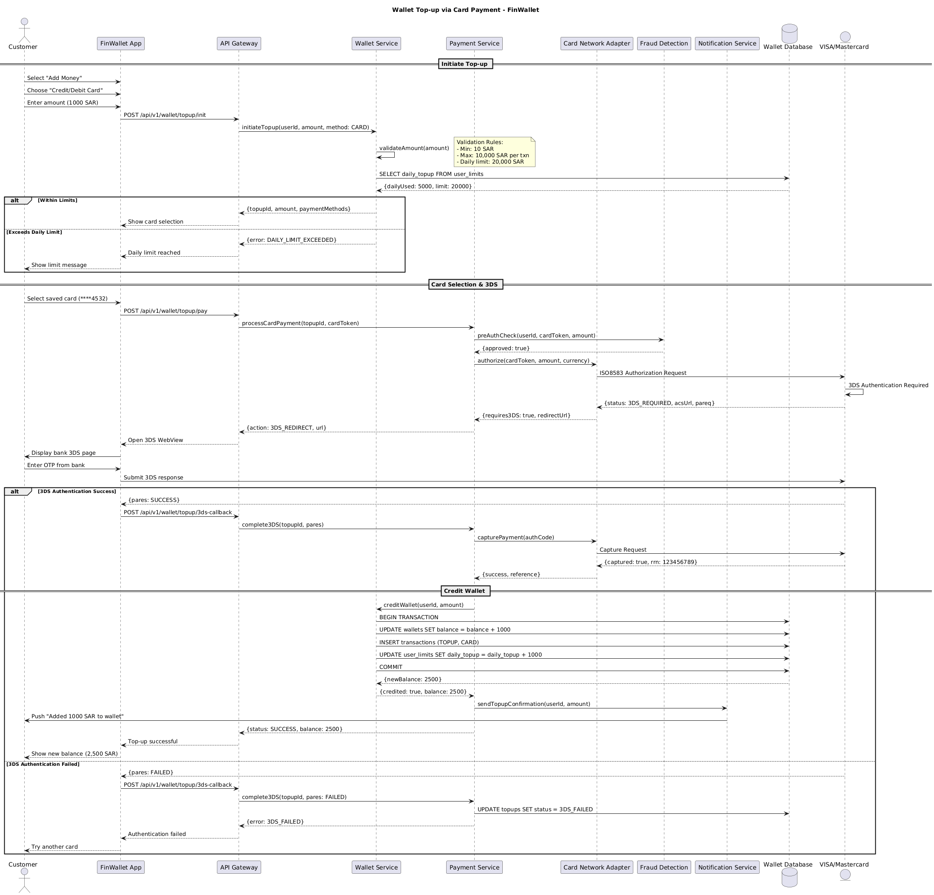

5.2. Flow Description
Initiate Top-up
• The customer selects "Add Money" and chooses "Credit/Debit Card."
• The customer enters the amount (1000 SAR) to be added.
• The FinWallet App initiates the top-up process by sending a POST request to the API Gateway.
• The API Gateway validates the amount and forwards the request to the Wallet Service.
• The Wallet Service internally validates the amount and checks the daily top-up limit.
• If the daily limit is exceeded, the Wallet Service sends an error message to the API Gateway, which in turn informs the customer.
• If the daily limit is within limits, the Wallet Service sends a response to the API Gateway with the top-up ID, amount, and payment methods.
• The API Gateway then shows the card selection screen to the customer.
Card Selection & 3DS
• The customer selects a saved card (****4532).
• The FinWallet App sends a POST request to the API Gateway to initiate the payment process.
• The API Gateway forwards the request to the Payment Service, which processes the card payment.
• The Payment Service performs a pre-authentication check and an authorization request to the Card Network Adapter.
• The Card Network Adapter initiates a 3DS authentication process.
• If the 3DS authentication is successful, the Payment Service completes the transaction, captures the payment, and updates the wallet balance.
• If the 3DS authentication fails, the Payment Service marks the transaction as failed and sends an error message back to the API Gateway.
Credit Wallet
• The Payment Service credits the wallet balance and updates the user limits.
• The Wallet Service commits the transaction to the database.
• The Notification Service sends a confirmation message to the customer.
• The API Gateway confirms the successful top-up and updates the customer's balance.
  - SUB### Authentication & Validation
Validation Rules
• The Wallet Service validates the amount to ensure it is within the minimum (10 SAR) and maximum (10,000 SAR per transaction) limits.
• The Wallet Service checks the daily top-up limit, which is 20,000 SAR per day.
• If the daily limit is exceeded, the Wallet Service sends an error message to the API Gateway, which informs the customer.
3DS Authentication
• If the 3DS authentication is successful, the Payment Service completes the transaction, captures the payment, and updates the wallet balance.
• If the 3DS authentication fails, the Payment Service marks the transaction as failed and sends an error message back to the API Gateway.
  - SUB### Self-Interactions
Wallet Service
• The Wallet Service internally performs the validation of the amount.
• The Wallet Service internally performs the validation of the daily top-up limit.
Payment Service
• The Payment Service internally performs the pre-authentication check.
• The Payment Service internally performs the authorization request to the Card Network Adapter.
• The Payment Service internally completes the transaction, captures the payment, and updates the wallet balance.
Card Network Adapter
• The Card Network Adapter internally performs the 3DS authentication process.
  - SUB### Control Structures & Conditions
Conditional Branching
• If the daily top-up limit is exceeded, the flow terminates early, and the customer is informed of the daily limit reached.
• If the 3DS authentication is successful, the transaction is completed, and the customer is notified of the successful top-up.
• If the 3DS authentication fails, the transaction is marked as failed, and the customer is prompted to try another card.
Optional Execution Paths
• If the daily top-up limit is within limits, the customer is shown the card selection screen.
• If the 3DS authentication is successful, the transaction is completed, and the customer is notified of the successful top-up.
• If the 3DS authentication fails, the transaction is marked as failed, and the customer is prompted to try another card.
Repetitive Behavior
• The Wallet Service internally performs the validation of the daily top-up limit, which is repeated for each transaction.
• The Payment Service internally completes the transaction, captures the payment, and updates the wallet balance, which is repeated for each successful top-up.
Parallel Execution
• The 3DS authentication process is performed in parallel, ensuring that the customer's transaction is not interrupted by the authentication process.
Protected or Synchronized Execution
• The 3DS authentication process is protected to ensure that the transaction is not interrupted by the authentication process

5.3. APIs Contract Agreement
# | Source | Destination | API | Protocol | Request Parameters | Response Parameters
1 | FinWallet App | API Gateway | POST /api/v1/wallet/topup/init | REST |  | Show card selection
2 | API Gateway | Wallet Service | initiateTopup | REST | userId, amount, method: CARD | {topupId, amount, paymentMethods}
3 | Wallet Service | Wallet Database | SELECT daily_topup FROM user_limits | JDBC |  | {dailyUsed: 5000, limit: 20000}
4 | FinWallet App | API Gateway | POST /api/v1/wallet/topup/pay | REST |  | Open 3DS WebView
5 | API Gateway | Payment Service | processCardPayment | REST | topupId, cardToken | {action: 3DS_REDIRECT, url}
6 | Payment Service | Fraud Detection | preAuthCheck | REST | userId, cardToken, amount | {approved: true}
7 | Payment Service | Card Network Adapter | authorize | REST | cardToken, amount, currency | {requires3DS: true, redirectUrl}
8 | Card Network Adapter | VISA/Mastercard | ISO8583 Authorization Request | REST |  | {status: 3DS_REQUIRED, acsUrl, pareq}
9 | FinWallet App | Customer | Display bank 3DS page | REST
10 | FinWallet App | VISA/Mastercard | Submit 3DS response | REST |  | {pares: SUCCESS}
11 | FinWallet App | API Gateway | POST /api/v1/wallet/topup/3ds-callback | REST |  | Top-up successful
12 | API Gateway | Payment Service | complete3DS | REST | topupId, pares | {status: SUCCESS, balance: 2500}
13 | Payment Service | Card Network Adapter | capturePayment | REST | authCode | {success, reference}
14 | Card Network Adapter | VISA/Mastercard | Capture Request | REST |  | {captured: true, rrn: 123456789}
15 | Payment Service | Wallet Service | creditWallet | REST | userId, amount | {credited: true, balance: 2500}
16 | Wallet Service | Wallet Database | BEGIN TRANSACTION | JDBC |  | {newBalance: 2500}
17 | Wallet Service | Wallet Database | UPDATE wallets SET balance = balance + 1000 | JDBC
18 | Wallet Service | Wallet Database | INSERT transactions | JDBC | TOPUP, CARD
19 | Wallet Service | Wallet Database | UPDATE user_limits SET daily_topup = daily_topup + 1000 | JDBC
20 | Wallet Service | Wallet Database | COMMIT | JDBC
21 | Payment Service | Notification Service | sendTopupConfirmation | REST | userId, amount
22 | Notification Service | Customer | Push "Added 1000 SAR to wallet" | REST
23 | FinWallet App | API Gateway | POST /api/v1/wallet/topup/3ds-callback | REST |  | Authentication failed
24 | API Gateway | Payment Service | complete3DS | REST | topupId, pares: FAILED | {error: 3DS_FAILED}
25 | Payment Service | Wallet Database | UPDATE topups SET status = 3DS_FAILED | JDBC
[*] Indicates that the data element is optional

5.4. Error Handling
# | Source | Destination | Scenario | Handling
1 | External APIC | ACE-Integration | createInternationalBeneficiaryRequest  Duplicate request detected | Ensure idempotency to avoid duplicates on retry; Log error with correlation ID; Retry up to 3 times with exponential backoff; Notify user of failure
2 | External APIC | ACE-Integration | getInternationalBeneficiarySupportedCountries  Data not found | Ensure idempotency to avoid duplicates on retry; Log error with correlation ID; Return cached response if available; Notify user of failure
3 | External APIC | ACE-Integration | createInternationalBeneficiaryRequest  Validation failure | Ensure idempotency to avoid duplicates on retry; Log error with correlation ID; Queue request for asynchronous retry; Notify user of failure
4 | External APIC | ACE-Integration | createInternationalBeneficiaryRequest  Partial completion | Ensure idempotency to avoid duplicates on retry; Log error with correlation ID; Queue request for asynchronous retry; Notify user of failure
5 | External APIC | ACE-Integration | createInternationalBeneficiaryRequest  Service unavailability | Ensure idempotency to avoid duplicates on retry; Log error with correlation ID; Queue request for asynchronous retry; Notify user of failure
6 | External APIC | ACE-Integration | createInternationalBeneficiaryRequest  Timeout | Ensure idempotency to avoid duplicates on retry; Log error with correlation ID; Queue request for asynchronous retry; Notify user of failure
7 | External APIC | ACE-Integration | createInternationalBeneficiaryRequest  Duplicate request detected (repeated) | Ensure idempotency to avoid duplicates on retry; Log error with correlation ID; Queue request for asynchronous retry; Notify user of failure
8 | External APIC | ACE-Integration | createInternationalBeneficiaryRequest  Service unavailability (repeated) | Ensure idempotency to avoid duplicates on retry; Log error with correlation ID; Queue request for asynchronous retry; Notify user of failure
9 | External APIC | ACE-Integration | createInternationalBeneficiaryRequest  Timeout (repeated) | Ensure idempotency to avoid duplicates on retry; Log error with correlation ID; Queue request for asynchronous retry; Notify user of failure
10 | External APIC | ACE-Integration | createInternationalBeneficiaryRequest  Validation failure (repeated) | Ensure idempotency to avoid duplicates on retry; Log error with correlation ID; Queue request for asynchronous retry; Notify user of failure
11 | External APIC | ACE-Integration | createInternationalBeneficiaryRequest  Partial completion (repeated) | Ensure idempotency to avoid duplicates on retry; Log error with correlation ID; Queue request for asynchronous retry; Notify user of failure
12 | External APIC | ACE-Integration | createInternationalBeneficiaryRequest  Service unavailability (repeated) | Ensure idempotency to avoid duplicates on retry; Log error with correlation ID; Queue request for asynchronous retry; Notify user of failure
13 | External APIC | ACE-Integration | createInternationalBeneficiaryRequest  Timeout (repeated) | Ensure idempotency to avoid duplicates on retry; Log error with correlation ID; Queue request for asynchronous retry; Notify user of failure
14 | External APIC | ACE-Integration | createInternationalBeneficiaryRequest  Validation failure (repeated) | Ensure idempotency to avoid duplicates on retry; Log error with correlation ID; Queue request for asynchronous retry; Notify user of failure
15 | External APIC | ACE-Integration | createInternationalBeneficiaryRequest  Partial completion (repeated) | Ensure idempotency to avoid duplicates on retry; Log error with correlation ID; Queue request for asynchronous retry; Notify user of failure
16 | External APIC | ACE-Integration | createInternationalBeneficiaryRequest  Service unavailability (repeated) | Ensure idempotency to avoid duplicates on retry; Log error with correlation ID; Queue request for asynchronous retry; Notify user of failure
17 | External APIC | ACE-Integration | createInternationalBeneficiaryRequest  Timeout (repeated) | Ensure idempotency to avoid duplicates on retry; Log error with correlation ID; Queue request for asynchronous retry; Notify user of failure
18 | External APIC | ACE-Integration | createInternationalBeneficiaryRequest  Validation failure (repeated) | Ensure idempotency to avoid duplicates on retry; Log error with correlation ID; Queue request for asynchronous retry; Notify user of failure
19 | External APIC | ACE-Integration | createInternationalBeneficiaryRequest  Partial completion (repeated) | Ensure idempotency to avoid duplicates on retry; Log error with correlation ID; Queue request for asynchronous retry; Notify user of failure
20 | External APIC | ACE-Integration | createInternationalBeneficiaryRequest  Service unavailability (repeated) | Ensure idempotency to avoid duplicates on retry; Log error with correlation ID; Queue request for asynchronous retry; Notify user of failure
21 | External APIC | ACE-Integration | createInternationalBeneficiaryRequest  Timeout (repeated) | Ensure idempotency to avoid duplicates on retry; Log error with correlation ID; Queue request for asynchronous retry; Notify user of failure
22 | External APIC | ACE-Integration | createInternationalBeneficiaryRequest  Validation failure (repeated) | Ensure idempotency to avoid duplicates on retry; Log error with correlation ID; Queue request for asynchronous retry; Notify user of failure
23 | External APIC | ACE-Integration | createInternationalBeneficiaryRequest  Partial completion (repeated) | Ensure idempotency to avoid duplicates on retry; Log error with correlation ID; Queue request for asynchronous retry; Notify user of failure
24 | External APIC | ACE-Integration | createInternationalBeneficiaryRequest  Service unavailability (repeated) | Ensure idempotency to avoid duplicates on retry; Log error with correlation ID; Queue request for asynchronous retry; Notify user of failure
25 | External APIC | ACE-Integration | createInternationalBeneficiaryRequest  Timeout (repeated) | Ensure idempotency to avoid duplicates on retry; Log error with correlation ID; Queue request for asynchronous retry; Notify user of failure
26 | External APIC | ACE-Integration | createInternationalBeneficiaryRequest  Validation failure (repeated) | Ensure idempotency to avoid duplicates on retry; Log error with correlation ID; Queue request for asynchronous retry; Notify user of failure
27 | External APIC | ACE-Integration | createInternationalBeneficiaryRequest  Partial completion (repeated) | Ensure idempotency to avoid duplicates on retry; Log error with correlation ID; Queue request for asynchronous retry; Notify user of failure
28 | External APIC | ACE-Integration | createInternationalBeneficiaryRequest  Service unavailability (repeated) | Ensure idempotency to avoid duplicates on retry; Log error with correlation ID; Queue request for asynchronous retry; Notify user of failure
29 | External APIC | ACE-Integration | createInternationalBeneficiaryRequest  Timeout (repeated) | Ensure idempotency to avoid duplicates on retry; Log error with correlation ID; Queue request for asynchronous retry; Notify user of failure
30 | External APIC | ACE-Integration | createInternationalBeneficiaryRequest  Validation failure (repeated) | Ensure idempotency to avoid duplicates on retry; Log error with correlation ID; Queue request for asynchronous retry; Notify user of failure
31 | External APIC | ACE-Integration | createInternationalBeneficiaryRequest  Partial completion (repeated) | Ensure idempotency to avoid duplicates on retry; Log error with correlation ID; Queue request for asynchronous retry; Notify user of failure
32 | External APIC | ACE-Integration | createInternationalBeneficiaryRequest  Service unavailability (repeated) | Ensure idempotency to avoid duplicates on retry; Log error with correlation ID; Queue request for asynchronous retry; Notify user of failure
33 | External APIC | ACE-Integration | createInternationalBeneficiaryRequest  Timeout (repeated) | Ensure idempotency to avoid duplicates on retry; Log error with correlation ID; Queue request for asynchronous retry; Notify user of failure
34 | External APIC | ACE-Integration | createInternationalBeneficiaryRequest  Validation failure (repeated) | Ensure idempotency to avoid duplicates on retry; Log error with correlation ID; Queue request for asynchronous retry; Notify user of failure
35 | External APIC | ACE-Integration | createInternationalBeneficiaryRequest  Partial completion (repeated) | Ensure idempotency to avoid duplicates on retry; Log error with correlation ID; Queue request for asynchronous retry; Notify user of failure
36 | External APIC | ACE-Integration | createInternationalBeneficiaryRequest  Service unavailability (repeated) | Ensure idempotency to avoid duplicates on retry; Log error with correlation ID; Queue request for asynchronous retry; Notify user of failure
37 | External APIC | ACE-Integration | createInternationalBeneficiaryRequest  Timeout (repeated) | Ensure idempotency to avoid duplicates on retry; Log error with correlation ID; Queue request for asynchronous retry; Notify user of failure
38 | External APIC | ACE-Integration | createInternationalBeneficiaryRequest  Validation failure (repeated) | Ensure idempotency to avoid duplicates on retry; Log error with correlation ID; Queue request for asynchronous retry; Notify user of failure
39 | External APIC | ACE-Integration | createInternationalBeneficiaryRequest  Partial completion (repeated) | Ensure idempotency to avoid duplicates on retry; Log error with correlation ID; Queue request for asynchronous retry; Notify user of failure
40 | External APIC | ACE-Integration | createInternationalBeneficiaryRequest  Service unavailability (repeated) | Ensure idempotency to avoid duplicates on retry; Log error with correlation ID; Queue request for asynchronous retry; Notify user of failure
41 | External APIC | ACE-Integration | createInternationalBeneficiaryRequest  Timeout (repeated) | Ensure idempotency to avoid duplicates on retry; Log error with correlation ID; Queue request for asynchronous retry; Notify user of failure
42 | External APIC | ACE-Integration | createInternationalBeneficiaryRequest  Validation failure (repeated) | Ensure idempotency to avoid duplicates on retry; Log error with correlation ID; Queue request for asynchronous retry; Notify user of failure
43 | External APIC | ACE-Integration | createInternationalBeneficiaryRequest  Partial completion (repeated) | Ensure idempotency to avoid duplicates on retry; Log error with correlation ID; Queue request for asynchronous retry; Notify user of failure
44 | External APIC | ACE-Integration | createInternationalBeneficiaryRequest  Service unavailability (repeated) | Ensure idempotency to avoid duplicates on retry; Log error with correlation ID; Queue request for asynchronous retry; Notify user of failure
45 | External APIC | ACE-Integration | createInternationalBeneficiaryRequest  Timeout (repeated) | Ensure idempotency to avoid duplicates on retry; Log error with correlation ID; Queue request for asynchronous retry; Notify user of failure
46 | External APIC | ACE-Integration | createInternationalBeneficiaryRequest  Validation failure (repeated) | Ensure idempotency to avoid duplicates on retry; Log error with correlation ID; Queue request for asynchronous retry; Notify user of failure
47 | External APIC | ACE-Integration | createInternationalBeneficiaryRequest  Partial completion (repeated) | Ensure idempotency to avoid duplicates on retry; Log error with correlation ID; Queue request for asynchronous retry; Notify user of failure
48 | External APIC | ACE-Integration | createInternationalBeneficiaryRequest  Service unavailability (repeated) | Ensure idempotency to avoid duplicates on retry; Log error with correlation ID; Queue request for asynchronous retry; Notify user of failure
49 | External APIC | ACE-Integration | createInternationalBeneficiaryRequest  Timeout (repeated) | Ensure idempotency to avoid duplicates on retry; Log error with correlation ID; Queue request for asynchronous retry; Notify user of failure
50 | External APIC | ACE-Integration | createInternationalBeneficiaryRequest  Validation failure (repeated) | Ensure idempotency to avoid duplicates on retry; Log error with correlation ID; Queue request for asynchronous retry; Notify user of failure
51 | External APIC | ACE-Integration | createInternationalBeneficiaryRequest  Partial completion (repeated) | Ensure idempotency to avoid duplicates on retry; Log error with correlation ID; Queue request for asynchronous retry; Notify user of failure
52 | External APIC | ACE-Integration | createInternationalBeneficiaryRequest  Service unavailability (repeated) | Ensure idempotency to avoid duplicates on retry; Log error with correlation ID; Queue request for asynchronous retry; Notify user of failure
53 | External APIC | ACE-Integration | createInternationalBeneficiaryRequest  Timeout (repeated) | Ensure idempotency to avoid duplicates on retry; Log error with correlation ID; Queue request for asynchronous retry; Notify user of failure
54 | External APIC | ACE-Integration | createInternationalBeneficiaryRequest  Validation failure (repeated) | Ensure idempotency to avoid duplicates on retry; Log error with correlation ID; Queue request for asynchronous retry; Notify user of failure
55 | External APIC | ACE-Integration | createInternationalBeneficiaryRequest  Partial completion (repeated) | Ensure idempotency to avoid duplicates on retry; Log error with correlation ID; Queue request for asynchronous retry; Notify user of failure
56 | External APIC | ACE-Integration | createInternationalBeneficiaryRequest  Service unavailability (repeated) | Ensure idempotency to avoid duplicates on retry; Log error with correlation ID; Queue request for asynchronous retry; Notify user of failure
57 | External APIC | ACE-Integration | createInternationalBeneficiaryRequest  Timeout (repeated) | Ensure idempotency to avoid duplicates on retry; Log error with correlation ID; Queue request for asynchronous retry; Notify user of failure
58 | External APIC | ACE-Integration | createInternationalBeneficiaryRequest  Validation failure (repeated) | Ensure idempotency to avoid duplicates on retry; Log error with correlation ID; Queue request for asynchronous retry; Notify user of failure
59 | External APIC | ACE-Integration | createInternationalBeneficiaryRequest  Partial completion (repeated) | Ensure idempotency to avoid duplicates on retry; Log error with correlation ID; Queue request for asynchronous retry; Notify user of failure
60 | External APIC | ACE-Integration | createInternationalBeneficiaryRequest  Service unavailability (repeated) | Ensure idempotency to avoid duplicates on retry; Log error with correlation ID; Queue request for asynchronous retry; Notify user of failure
61 | External APIC | ACE-Integration | createInternationalBeneficiaryRequest  Timeout (repeated) | Ensure idempotency to avoid duplicates on retry; Log error with correlation ID; Queue request for asynchronous retry; Notify user of failure
62 | External APIC | ACE-Integration | createInternationalBeneficiaryRequest  Validation failure (repeated) | Ensure idempotency to avoid duplicates on retry; Log error

6. Peer-to-Peer Fund Transfer

6.1. Sequence Diagram
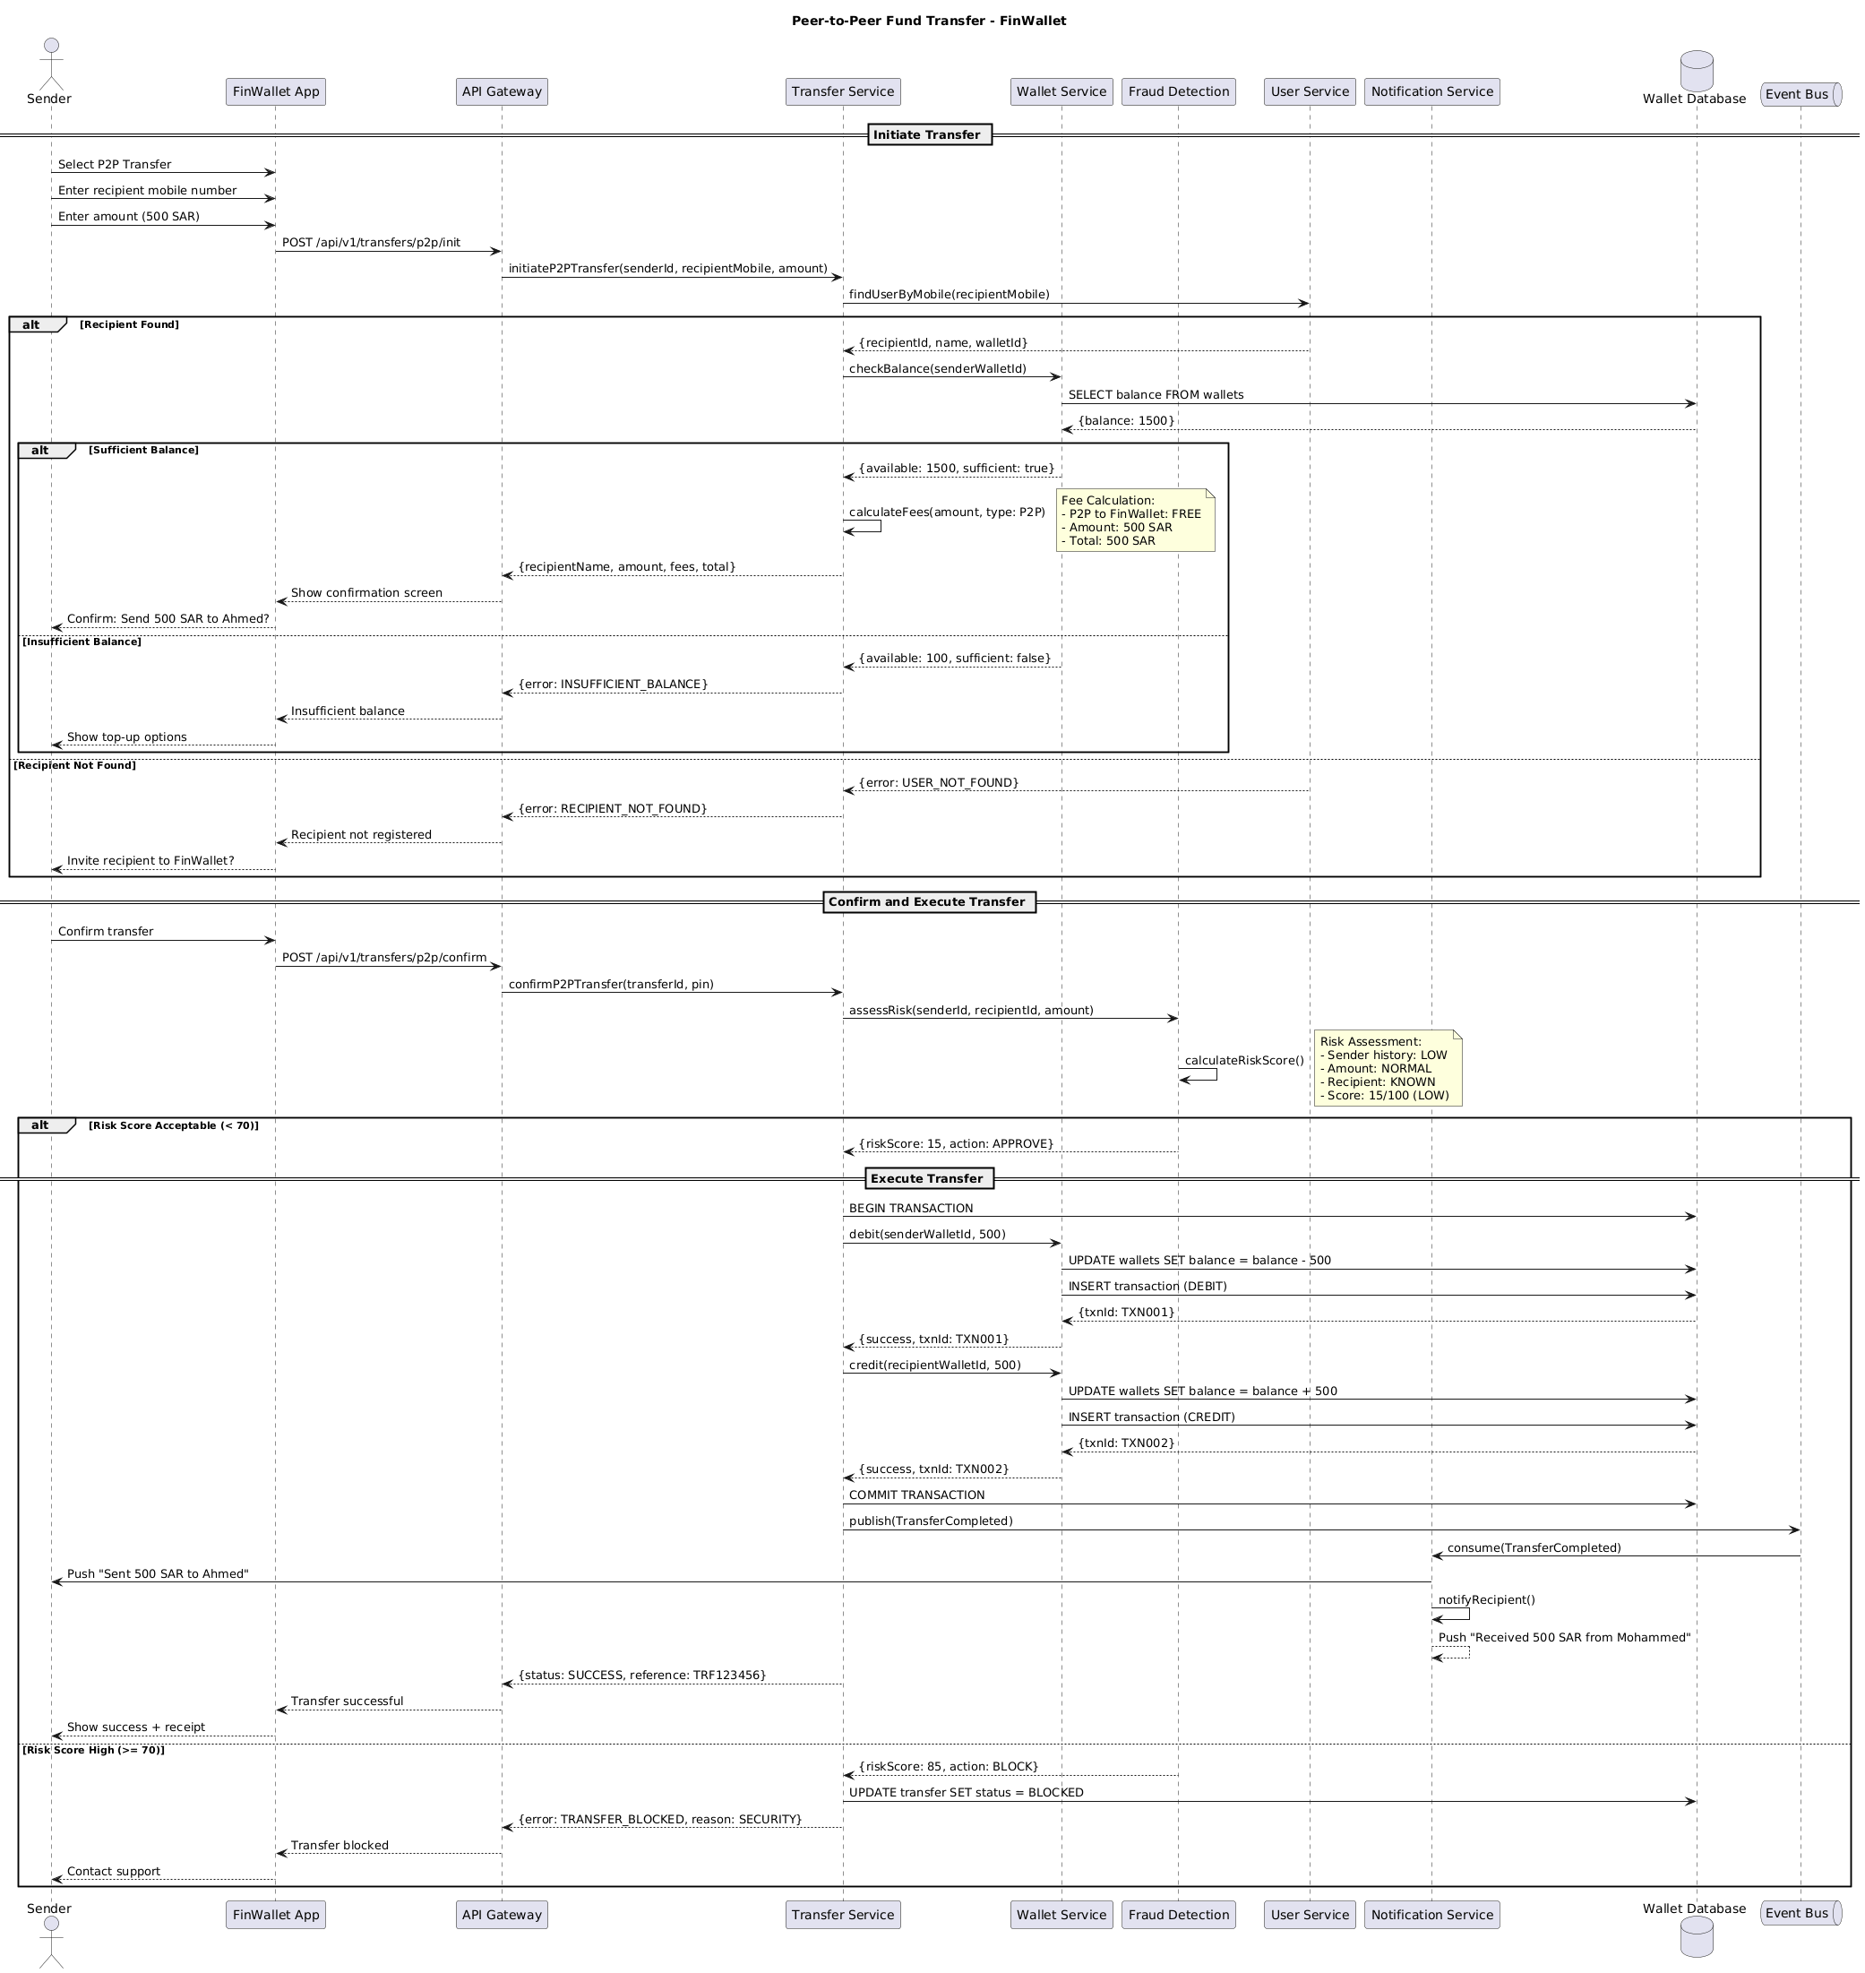

6.2. Flow Description
Initiate Transfer
• The sender initiates a P2P transfer by selecting the transfer option and entering the recipient's mobile number and the amount.
• The FinWallet app sends a POST request to the API Gateway to initiate the transfer.
• The API Gateway forwards the request to the Transfer Service, which then calls the User Service to find the recipient's user details.
• If the recipient is found, the Transfer Service calls the Wallet Service to check the sender's balance.
• If the balance is sufficient, the Transfer Service calculates the fees and sends a response back to the API Gateway.
• The API Gateway shows a confirmation screen to the sender, asking for confirmation of the transfer.
• If the sender confirms, the Transfer Service calls the Fraud Detection service to assess the risk.
• The Fraud Detection service calculates a risk score and decides whether to approve or block the transfer based on the score.
Confirm and Execute Transfer
• If the risk score is acceptable, the Transfer Service approves the transfer.
• The Transfer Service then executes the transfer by debiting the sender's wallet and crediting the recipient's wallet.
• The Transfer Service commits the transaction and publishes a completion event to the Event Bus.
• The Event Bus notifies the Notification Service, which in turn sends push notifications to the sender and the recipient.
• The API Gateway confirms the transfer status and sends a success message to the sender.
• If the risk score is high, the Transfer Service blocks the transfer and sends an error message to the API Gateway and the sender.
Execute Transfer
• The Transfer Service begins the transaction by calling the Wallet Database to start a transaction.
• The Transfer Service debits the sender's wallet and credits the recipient's wallet.
• The Wallet Database updates the transaction records and commits the transaction.
• The Transfer Service publishes a completion event to the Event Bus.
• The Event Bus notifies the Notification Service, which sends push notifications to the sender and the recipient.
• The API Gateway confirms the transfer status and sends a success message to the sender.
  - Authentication & Validation
• The sender's identity is validated by the User Service through the recipient's mobile number.
• The recipient's existence is verified by the User Service.
• The sender's balance is checked by the Wallet Service.
• The risk assessment is performed by the Fraud Detection service, which calculates a risk score based on the sender's history, the amount, and the recipient's known status.
• The transaction is executed in a protected execution scope to ensure data integrity and security.
  - Control Structures & Conditions
• The flow includes conditional branches based on the recipient's existence and the sender's balance.
• The risk assessment uses a conditional branch to determine whether to approve or block the transfer based on the calculated risk score.
• The transaction execution is protected by a transaction scope to ensure data consistency and integrity.
  - Notes
• Fee Calculation: The Transfer Service calculates the fees for a P2P transfer to FinWallet, which is free. The total amount is 500 SAR.
• Risk Assessment: The Fraud Detection service calculates a risk score based on the sender's history, the amount, and the recipient's known status. If the score is 15/100, the transfer is approved. If the score is 85/100, the transfer is blocked.

6.3. APIs Contract Agreement
# | Source | Destination | API | Protocol | Request Parameters | Response Parameters
1 | FinWallet App | API Gateway | POST /api/v1/transfers/p2p/init | REST |  | Show confirmation screen
2 | API Gateway | Transfer Service | initiateP2PTransfer | REST | senderId, recipientMobile, amount | {recipientName, amount, fees, total}
3 | Transfer Service | User Service | findUserByMobile | REST | recipientMobile | {recipientId, name, walletId}
4 | Transfer Service | Wallet Service | checkBalance | REST | senderWalletId | {available: 1500, sufficient: true}
5 | Wallet Service | Wallet Database | SELECT balance FROM wallets | JDBC |  | {balance: 1500}
6 | FinWallet App | API Gateway | POST /api/v1/transfers/p2p/confirm | REST |  | Transfer successful
7 | API Gateway | Transfer Service | confirmP2PTransfer | REST | transferId, pin | {status: SUCCESS, reference: TRF123456}
8 | Transfer Service | Fraud Detection | assessRisk | REST | senderId, recipientId, amount | {riskScore: 15, action: APPROVE}
9 | Transfer Service | Wallet Database | BEGIN TRANSACTION | JDBC
10 | Transfer Service | Wallet Service | debit | REST | senderWalletId, 500 | {success, txnId: TXN001}
11 | Wallet Service | Wallet Database | UPDATE wallets SET balance = balance - 500 | JDBC |  | {txnId: TXN001}
12 | Wallet Service | Wallet Database | INSERT transaction | JDBC | DEBIT | {txnId: TXN002}
13 | Transfer Service | Wallet Service | credit | REST | recipientWalletId, 500 | {success, txnId: TXN002}
14 | Wallet Service | Wallet Database | UPDATE wallets SET balance = balance + 500 | JDBC
15 | Wallet Service | Wallet Database | INSERT transaction | JDBC | CREDIT
16 | Transfer Service | Wallet Database | COMMIT TRANSACTION | JDBC
17 | Transfer Service | Event Bus | publish | REST | TransferCompleted
18 | Event Bus | Notification Service | consume | REST | TransferCompleted
19 | Notification Service | Sender | Push "Sent 500 SAR to Ahmed" | REST
20 | Transfer Service | Wallet Database | UPDATE transfer SET status = BLOCKED | JDBC
[*] Indicates that the data element is optional

7. Bill Payment via SADAD

7.1. Sequence Diagram
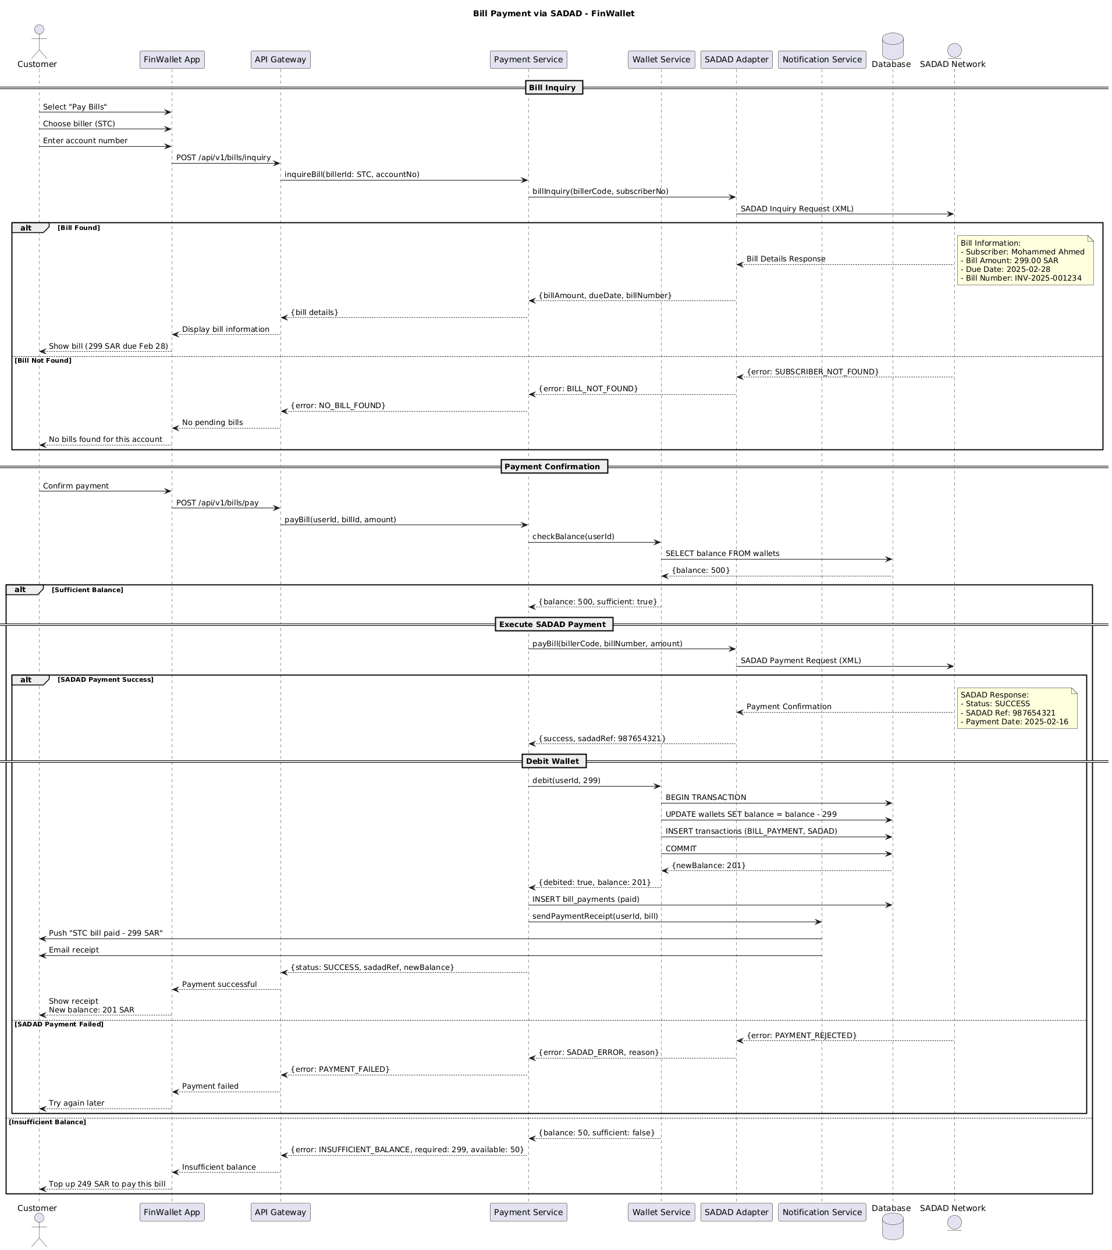

7.2. Flow Description
  - Overview of Bill Inquiry
• Customer Interaction: The customer selects "Pay Bills" and chooses the biller. They then enter their account number.
• API Gateway Interaction: The FinWallet app sends a POST request to the API Gateway to initiate the bill inquiry. The API Gateway then forwards this request to the Payment Service.
• Payment Service Interaction: The Payment Service communicates with the SADAD Adapter to fetch the bill details. This interaction involves sending a bill inquiry request to the SADAD Network.
• Conditional Branching: If the bill is found, the system displays the bill details to the customer. If the bill is not found, the system informs the customer that there are no pending bills.
• Internal Processing: The system internally handles the display of the bill information and the confirmation of the payment.
  - Detailed Description of Bill Inquiry
• Customer Interaction: The customer selects "Pay Bills" and chooses the biller. They enter their account number.
• API Gateway Interaction: The FinWallet app sends a POST request to the API Gateway to initiate the bill inquiry. The API Gateway then forwards this request to the Payment Service.
• Payment Service Interaction: The Payment Service communicates with the SADAD Adapter to fetch the bill details. This interaction involves sending a bill inquiry request to the SADAD Network.
• Conditional Branching: If the bill is found, the system internally displays the bill information. If the bill is not found, the system internally displays a message indicating no pending bills.
• Internal Processing: The system internally handles the display of the bill information and the confirmation of the payment.
  - Detailed Description of Payment Confirmation
Customer Interaction: The customer confirms the payment.
• API Gateway Interaction: The FinWallet app sends a POST request to the API Gateway to initiate the payment. The API Gateway then forwards this request to the Payment Service.
• Payment Service Interaction: The Payment Service checks the balance of the wallet service and initiates the payment process. This interaction involves checking the balance and initiating the payment.
• Conditional Branching: If the balance is sufficient, the system debits the wallet and sends a payment confirmation to the wallet service. If the balance is insufficient, the system prompts the customer to top up the balance.
• Internal Processing: The system internally handles the debiting of the wallet and the payment confirmation.
  - Detailed Description of Execute SADAD Payment
• Payment Service Interaction: The Payment Service initiates the payment process by sending a payment request to the SADAD Adapter. This interaction involves sending a payment request to the SADAD Network.
• Conditional Branching: If the payment is successful, the system handles the payment confirmation and debits the wallet. If the payment is unsuccessful, the system handles the payment failure and prompts the customer to try again later.
• Internal Processing: The system internally handles the debiting of the wallet and the payment confirmation.
  - Detailed Description of Debit Wallet
• Wallet Service Interaction: The Wallet Service debits the wallet and sends the transaction details to the database. This interaction involves debiting the wallet and sending the transaction details.
• Database Interaction: The Wallet Service sends the transaction details to the database for processing. This interaction involves sending the transaction details to the database.
• Internal Processing: The system internally handles the debiting of the wallet and the transaction confirmation.
  - Notes
• Bill Inquiry: The system internally handles the display of the bill information and the confirmation of the payment.
• Payment Confirmation: The system internally handles the debiting of the wallet and the payment confirmation.
• Execute SADAD Payment: The system internally handles the debiting of the wallet and the payment confirmation.
  - Authentication & Validation
The system validates the

7.3. APIs Contract Agreement
# | Source | Destination | API | Protocol | Request Parameters | Response Parameters
1 | FinWallet App | API Gateway | POST /api/v1/bills/inquiry | REST |  | Display bill information
2 | API Gateway | Payment Service | inquireBill | REST | billerId: STC, accountNo | {bill details}
3 | Payment Service | SADAD Adapter | billInquiry | REST | billerCode, subscriberNo | {billAmount, dueDate, billNumber}
4 | SADAD Adapter | SADAD Network | SADAD Inquiry Request | REST | XML | Bill Details Response
5 | FinWallet App | API Gateway | POST /api/v1/bills/pay | REST |  | Payment successful
6 | API Gateway | Payment Service | payBill | REST | userId, billId, amount | {status: SUCCESS, sadadRef, newBalance}
7 | Payment Service | Wallet Service | checkBalance | REST | userId | {balance: 500, sufficient: true}
8 | Wallet Service | Database | SELECT balance FROM wallets | JDBC |  | {balance: 500}
9 | Payment Service | SADAD Adapter | payBill | REST | billerCode, billNumber, amount | {success, sadadRef: 987654321}
10 | SADAD Adapter | SADAD Network | SADAD Payment Request | REST | XML | Payment Confirmation
11 | Payment Service | Wallet Service | debit | REST | userId, 299 | {debited: true, balance: 201}
12 | Wallet Service | Database | BEGIN TRANSACTION | JDBC |  | {newBalance: 201}
13 | Wallet Service | Database | UPDATE wallets SET balance = balance - 299 | JDBC
14 | Wallet Service | Database | INSERT transactions | JDBC | BILL_PAYMENT, SADAD
15 | Wallet Service | Database | COMMIT | JDBC
16 | Payment Service | Database | INSERT bill_payments | JDBC | paid
17 | Payment Service | Notification Service | sendPaymentReceipt | REST | userId, bill
18 | Notification Service | Customer | Push "STC bill paid - 299 SAR" | REST
19 | Notification Service | Customer | Email receipt | REST
[*] Indicates that the data element is optional

7.4. Error Handling
# | Source | Destination | Scenario | Handling
1 | External APIC | ACE-Integration | createInternationalBeneficiaryRequest  Duplicate request detected | Ensure idempotency to avoid duplicates on retry; Log error with correlation ID; Queue request for asynchronous retry
2 | External APIC | ACE-Integration | getInternationalBeneficiarySupportedCountries  Data not found | Ensure idempotency to avoid duplicates on retry; Log error with correlation ID; Return cached response if available

8. Appendix

8.1. Solution Architecture Reference Documents
# | Name | File
1 | BRD | Refer to Latest BRD Attached to JIRA Ticket

